

Computer Vision

Date 23-Feb-2022

Section-1

Submitted to faculty: Professor Mehul Raval

Date of Submission: 23-02-2022

Student Details

Computer Vision-Super Image Resolution

| Roll No. | Name of the Student | Name of the Program |
| --- | --- | --- |
| AU1940109 | Jap Purohit | CV |
| AU1940034 | Varun Deliwala | CV |
| AU1940267 | Sahil Miskeen | CV |
| AU1940142 | Shail Patel | CV |

Tasks performed this week

In the last week we were able to achieve significant results related to image denoising. The results of which are shared above. The resulting image is only about 70 percent accurate. In order to make it better we decided to have a look at the paper in a detailed manner. We found out that they have created small patches from the images in order to improve localization of the image so that the model can be trained better to locate at which parts of the image the noise effect is significant. We tried to create patches. The code of which has been shared below.

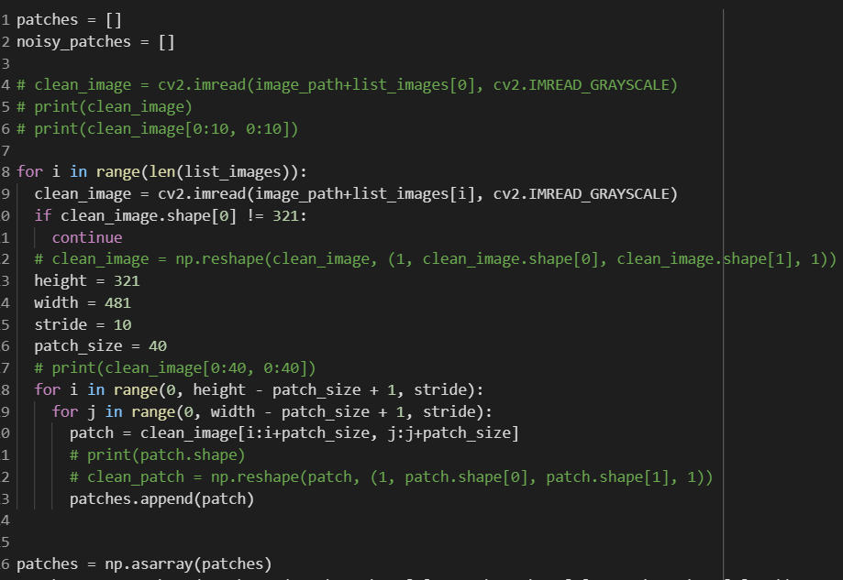

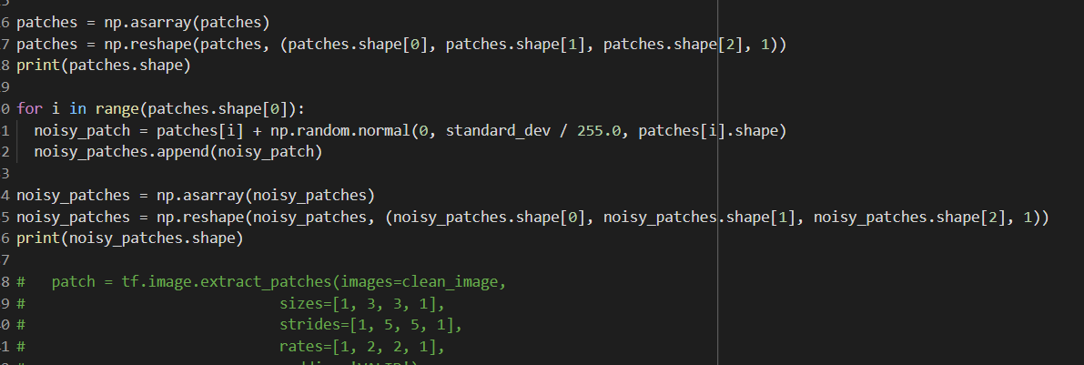

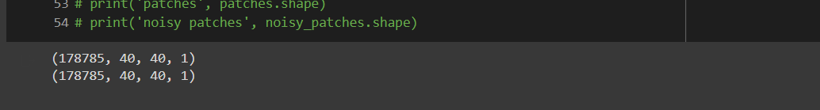

As observed above the dimensions of the dataset has been changed drastically. We will be now working on around 200000 images of dimensions 40*40 in grayscale. This would definitely help in improving localization of the image and lead to better results. On the other hand we made changes in the model as well. We studied the effect of some of the features being given more importance than others. We learn about batch normalization. We then thought of implementing batch normalization between the layers. This was done to ensure that some features are not given more importance than others. A change in the model has been shown below.

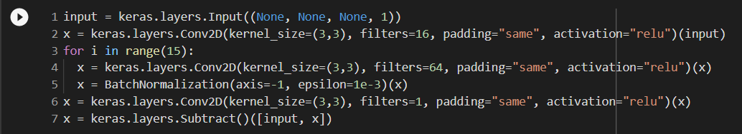

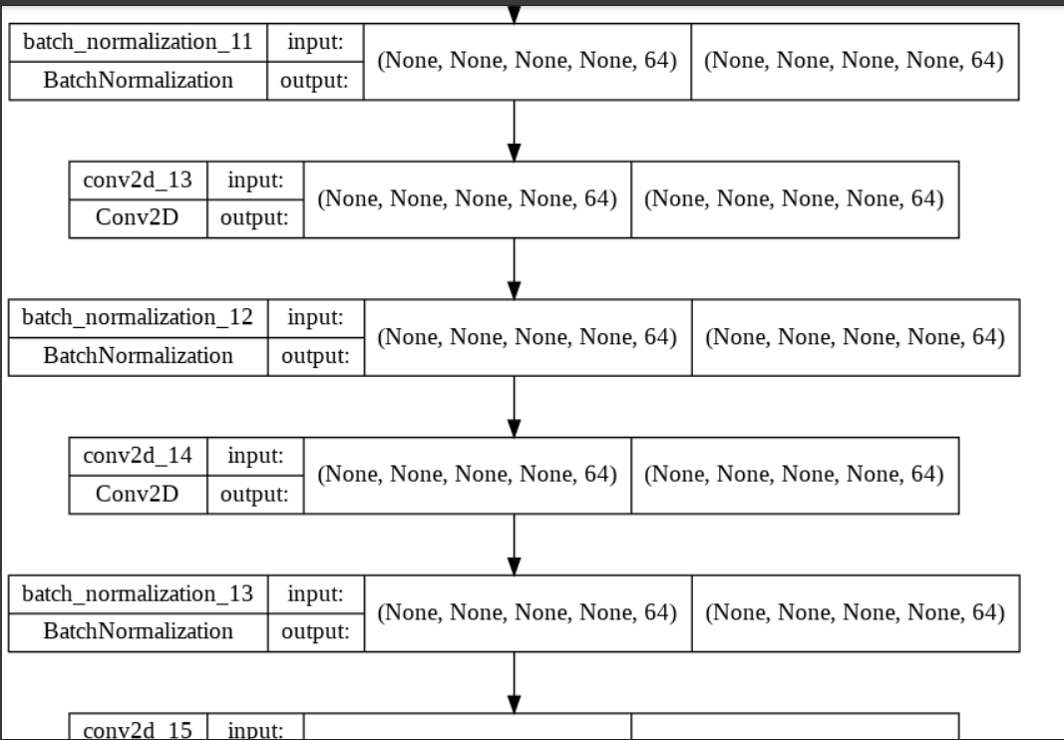



Moving along we had a look at a very primitive paper on super resolution. This paper simply passes the blurred image as input and the original image as output. We will be building this model in the next week and then after that we will be looking at GAN models work in order to start the final project preparation for the future.